

Project Code
Principal Investigator

Please provide confirmation of your proposal submission to the EUROPEAN COMMISSION - Horizon Europe. NB: To claim Stage 2 costs, you must provide evidence you attended the Stage 2 interview.

Required Information for Your Technical Report Submission

To ensure your Technical Report is accepted, please include the following:

- Proof of Proposal Submission
Attach a photo, scan, screenshot, or snip of the Receipt Email confirming your proposal submission.
- This must clearly display the submission date.
- Reports without this will be rejected.

- Proof of Stage 2 Interview (if applicable)
If you are claiming costs for a Stage 2 Interview, include a photo, scan, screenshot, or snip of the interview invitation email (or equivalent evidence).
- The interview date must be clearly visible.
- Reports without this will be rejected.

- Screenshot Requirements
The screenshot(s) must clearly show the following details:
- EU Commission strapline/logo
- Proposer name
- Proposal Acronym and/or Proposal Title
- Call/Activity Identifier
- Call Closure Date
- Date of submission

Example of screenshot:
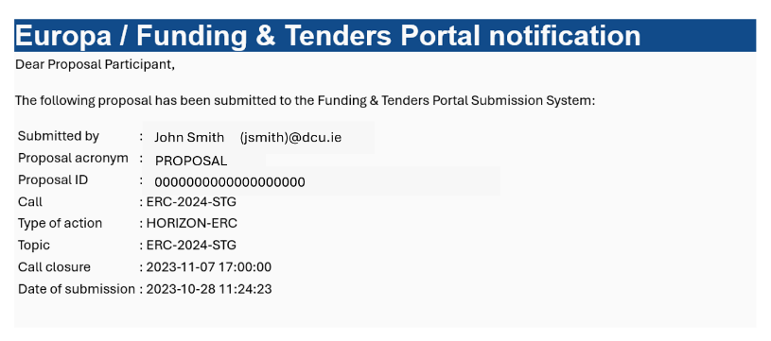

- Explanation of Discrepancies
If any of the above details differ significantly from your original grant application submitted to Enterprise Ireland, provide a brief explanation.
- Your Technical Report will be cross-referenced with your original application.

- Completeness
Incomplete Technical Reports will be automatically rejected.

INSERT HERE:

